My Health Online
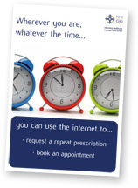
Patients can take a greater involvement in their own healthcare via the internet, in a similar way to shopping or banking online.

My Health Online gives patients the opportunity
- to book GP appointments
- order repeat prescriptions
- update their general details such as change of address
all from the convenience of your own computer or device.

Advantages of online services include:
- No hanging on the phone, waiting to get through to the GP surgery
- Convenient access to GP services from home or work — or anywhere with internet access
- Reduced administration for the GP practice

You need to call into your GP practice and sign up. Your GP will issue you with a registration letter.

